Abstract

Introduction

The theory of metapopulations has gained a lot of attention in the field of conservation biology ever since it was first proposed by Richard Levins in 1969. A metapopulation is defined as groups of populations of one species that are separated geographically but still interact at some level (Vrijenhoek, 2010). The driving forces behind metapopulation theory are source-sink dynamics and the constant balance between local extinctions and recolonization of suitable habitat (Hanski, 1998). The majority of research involving metapopulations focuses on how these driving forces affect geneflow and genetic diversity between populations. It is known that genetic diversity is essential for the long-term persistence of a species as it allows for the natural selection of novel traits which may become useful in an ever changing environment. An overlooked factor by conservation biologists, when determining the resilience of a species, is disease dynamics. Although geneflow in metapopulations is well studied, the epidemiology and dynamics of diseases in metapopulations are not that well understood. In order to get an accurate estimate of species survival, it is vital that we take into account both short-term (epidemiological) and long-term (genetic) factors to species persistence. In this paper we will focus specifically on modeling White Nose Syndrome and how it affects little brown bat (*Myotis lucifugus*) within a metapopulation.

White nose syndrome (WNS) is a fungal infection caused by *Pseudogymnoascus destructans*, which is responsible for the death of millions of bats across North America (Beekman, 2018). The first documented case of WNS was in February of 2006 in New York state, and now the disease has spread across the United States and Canada (Lorch et al, 2013). White nose syndrome affects bats by growing on the hairless parts of their bodies and causing frequent arousal from hibernation (CITATION). The frequent arousal of bats during hibernation results in high mortality rates during winter due to starvation. The mortality rate of this disease is very high with estimates between 90-100% depending on the study and is the leading cause of declines in bat populations (Wilder,2011). Due to the high mortality rate and rapid spread of White nose syndrome, it is of special concern to conservation biologists.

Bats play a very important role in many ecosystems and it is imperative that we understand how their populations will respond to WNS so that we can make informed conservation decisions. Bats are important pollinators as they travel longer distances than invertebrate pollinators such as bees, which allows isolated plants species to maintain effective reproduction rates (Arias-Cóyotl, 2006). Bats also play an important role in the long-distance dispersal of seeds across successional gradients as they are able to fly over fragmented habitat that other pollinators cannot traverse (Vleut et al, 2015). Bats are also responsible for regulating the population sizes of various insects, such as mosquitoes, that may be vectors for diseases that affect not only wildlife but also human populations (ie. West Nile, Malaria, Dengue …etc). Bats are often referred to as keystone species because of the large impact that they have on their environment, which is why it is important for us to understand how this disease might not only affect bat populations but our ecosystems as a whole.

To address the issue of WNS in metapopulations of little brown bats, we created a modified SIR model which takes into account metapopulations dynamics. In our model, we started off with one infected source population, from which bats will migrate to neighboring, empty patches. We determined a frequency dependent migration rate, based on previous studies, to determine the total number of bats leaving and entering each population. Finally, we ran our simulation for a period of 10 years to address the changes in the proportions of susceptible, infectious and recovered over a realistic time period.

Methods

Materials and Method

Model development)

To estimate the effects of WNS on the total bat population, we must first determine the interactions between subpopulations within the metapopulation. In our model we assume a spider metapopulation model in which there are 4 total patches, each patch is equally accessible to each individual from the main central population but, not equally accessible from peripheral patches (all individuals must return to the main population before moving to another patch). We assume this type of model as bats tend to migrate distances of between 35 – 554km which means if patches are spread out they are more likely to migrate to the intermediate, central patch rather than distant patches (Dubois & Monson, 2007). For our initial year (n0) we assume that there is only 1 occupied patch which contains the total population of bats within this metapopulation. We assume a frequency dependent migration rate (see Table 1) of the total population and we also assume that the likelihood of a bat migrating from the central patch to a peripheral patch is equal between all patches but if migrating from a peripheral patch the only outcome is migration to the central patch (Figure 1 (b)). Therefore, the migration rate going into the central population is µ, while the migration rate leaving the central population is µ/3 (µ/all possible patches).

To track the spread of the disease we use an SIR model for each subpopulation within the total metapopulation. In our SIR model we model the proportion of the population that is either susceptible (S), exposed (E), recently infected (I1) or infected for more than 1 year (I2) (see figure _ for flow diagram of model). An individual is considered susceptible if they do not have the infection and are not in contact with an infected individual. An individual is considered exposed if they are infected but are not showing symptoms. An individual is considered recently infected if they have contracted the disease within the year. An individual is considered infected for more than one year if they have been infected for more than one year. In our model we separate infected individuals based on how long they have been infected because there is research that shows mortality of recently infected individuals is lower than an individual has been infected for more than a year (Frick *et al,* 2010).

To see the effects of the disease in the metapopulation model, we now merge the SIR model with the metapopulation model. When we merge the two models, we are now able to see the change in dynamics due to migration to new patches. Since we assume no breeding, the only input of individuals into a subpopulation is from migration which allows us to track the spread of the disease easier. We track migration within the metapopulation as parts of each population migrating in the same proportion.

Calculations and parameterization

To determine the continuous change in population proportions within each category, we use ordinary differential equations (ODEs). The term β, in our ODEs, is used to indicate the transmissive contact rate between susceptible and exposed and infectious bats. The term T is used to indicate the rate of progression from exposed to infected annually. The term y was used to express the mean annual maturation rate of bats. The term a1 was used to express the probability of recovery of exposed and viable infectious bats. The value a2 was used to model the probability of recovery of bats that had been infected for 2 years or more. The term m1 was used to model the mortality rate of for bats that had been infected for 1 year. And the term m2 was used to model the mortality rate of bats that had been infected for more than 1 year. All terms can be found in figure 1 in the results section.

Model analysis

The main purpose of this model is to determine the resilience of native bat populations to WNS based on parameters taken from previous studies. As parameters change over time, due to various climatic and biotic variables, it is important to know how sensitive a population is to changes in variables. To address this issue we look at 3 variables that we believe might have the largest impact on the population: contact rate, migration rate and population size. To determine whether these values had a significant change on the population, we performed a sensitivity analysis in which we held all variables constant while varying the contact rate, and migration rate and a population viability analysis for varying population sizes.

Figure 1. A flow diagram of the spider metapopulation model

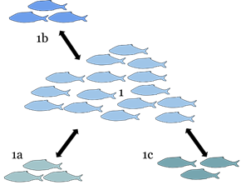

Introduction

Material and Methods

Results

*Parameter estimation and sensitivity analyses:*

Table 1 lists a summary of all the parameters involved and their estimates. We relied on previous studies to extract and estimate most of the parameters. Since we looked at the annual change in proportion of populations, some of the parameter values were estimated from daily values used by Meyer *et al.* (2016). For instance, the annual rate of progression from exposed to infected bats was estimated multiplying the known default value by 365 days/year ($\tau = 1/83 d^{-1} \times 365 d y^{-1} = 365/83 y^{-1}).

We performed sensitivity analyses for the transmissive contact rate between bats, $\beta$, and the migration rates between populations, $\mu$. Looking at the changes in the population dynamics with increasing transmissive contact rate, we see that there is always an immediate increase in the proportion of individuals exposed to WNS and the proportion of susceptible individuals declines rapidly. Even at a lower contact rate ($\beta = 100$) , the proportion of individuals exposed quickly rises up to 70\% of the population. At contact rates higher in the range estimated by Meyer *et al.* (2016), the proportion of individuals exposed quickly rises up to more than 95% of the population (Fig. 1).

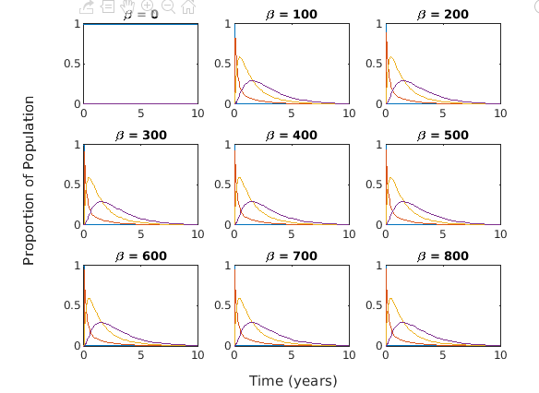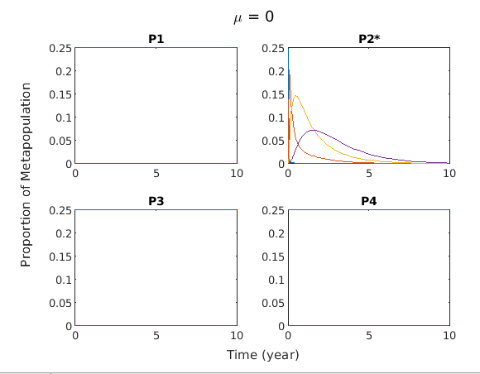

Discussion Conclusions

Edward make sure you relate the results to control measures that is one important part of the prompt.

You could talk about decreasing contact rate

Or increasing recovery rate.

Or decrease mortality

I’m so confused at what each graph represents directly. - Ed

First of all, might need to let us know what each coloured line represents.

Like is mu supposed to be percentages, and does it represent migration rates?

Also for the viability analysis of small and large populations, are we looking for smallest peaks or largest peaks?

Add the legend first then, we’ll be able to make sense of what’s presented.

The only reason I’m asking for the figure captions is cause we are going to need to discuss correlations. And that translates to possible revisitation of our hypothesis, which is “future modelling plans for content”

Shit sorry about the legend

I am going to just add an image that has the legend lines. Since its tough to add legend to subplots I will be mentioning it in the in the figure captions.

The legend for the graphs.

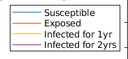

Is this all for adults? I presume so. What does the axis represents? Cause all I see is numbers with no terms for what they represents (x-axis and y-axis) All I’m asking is what do you want the axis. Gotcha. Can start working on it.

For the small and large population analysis, are we using a beta of 100 and what would be the value of mu? Okay.

No beta = 766.5/2 = 382.25

Mu = 0.04 as you had found I am going out of the library now. I will check this when i reach home.

Like obviously, this isnt the final form I send this to you so you can start working on the discussion. X axis is time in years

Y axis is proportion of population. Cool lemme know if you need antyhing else

If i think of any other pointers for discussion ill let you know. We need our discussion to be really strong because our results are really week.

Possible Results (Feel free to change at will to help describe the graphs better)

I’ll just hi-light it all in brown in just in case it’s wrong

To be able to predict the effects of fungal transmission within a population of little brown bat, we decided to assess whether the social behavioral dynamics of the little brown bat would have a major impact in transmitting the fungus from one roosting site of disease origin (simulation of a cave infested with P. destructans) to other hospitable roosting sites that are currently devoid of the fungus presence.

The social dynamics of the little brown bat that would allow the fungus to pass from an infected bat to an uninfected bat were split into two categories; the average contact rate between bats and the rate of migration between different roosting sites. Sensitivity analyses were carried out to try to determine the degree of impact the factors had on the transmission of the fungus between bats.

It was observed that when beta, also known as the contact rate between bats, was raised to any ranges above 100, in a simulated Levin’s model with equal sized populations and a migration rate of 0.04 (Norquay, 2013), the proportion of bats that are exposed to the fungus for a period of 1 year, in the whole population, would consistently peak after approximately 23 days and the proportion of bats that are exposed to the fungus for 2+ years, in the whole population, would consistently peak after a year, 8 months and 20 days. Would this mean that beta doesn’t have any effect since the peaks stay the same after any range of 100? No it actually increases from below 0.7 at 100 to >0.9 at beta = 700

When a sensitivity analysis was performed on mu, also known as the migration rate, on a simulated Levin’s model we havent used levins model with equal sized populations and a beta of 382.25, it was observed that when mu was raised above 0.02 (to a maximal range of 0.10 by increments of 0.01), the inflection point of the curves representing the proportions of bats infected with the fungus for 1 year and the proportion of bats infected with the fungus for 2+ years, in population 2, would rise by approximately 0.66% per increment of 0.01 increase in mu after a mu value of 0.02, while the inflection points of the curves representing the proportion of bats infected with the fungus for 1 year and the proportion of bats infected with the fungus for 2+ years, in population 1,3, and 4, would all drop by approximately 0.33% per increment of 0.01 increase in mu.

*Need references to why a beta value of 382.25 was chosen

Also mu is shown to be affecting the transmission rates of the bats to the other “populations” from population 1, but with the increase being quite small, it seems almost insignificant in affecting transmission rates.

When an assessment of the impact of the initial infective population size was performed, under a simulated Levin’s model with a beta of 382.25 and a mu of 0.04, it was observed that overall the proportion of infectives is higher in population 1 than the rest of the metapopulations if the initial amount of infective is low, but if the amount of infectives is high, the proportion of infectives in population 2 would be higher than the rest of the metapopulations, possibly acting as a source of infectives to all interconnected exterior metapopulations. It was also observed that in population 4, regardless of whether the initial population of infectives were in abundance or not, population 4 always seemed to have a higher proportion of bats that were infected with the fungus for 2+ years than the rest of the S.I model classes in population 4. All this seems to show me is that population 2 is becoming a source of infectives due to back-migration from the rest of the populations.

Discussion Guidelines

-Discuss any correlations found from the results

-Revisitng of predictions

-Possibilities for why results were as they were

-Underlying assumptions of our models

-Explain significance of model for predicting emerging diseases

-Explains impact of emerging diseases

-Importance of incorporating the social behaviour of hosts into understanding parasite transmission dynamics

Discussion (Importance of studies)

From our simulations of fungus transmittance through 4 little brown bats subpopulations through a timescale of 10 years, regardless of starting total population size prior to infection, it was observed that the mortality from the fungus would be completely eradicating the little brown bat total population before 10 years, without taking into consideration of natural mortality yet. This observation would be of high concern since the little brown bat average life span is around 6 – 10 years, showing that if conservative actions are not implemented quickly, it may be too late for a lot of the little brown bat populations in North America. While we did predict if the original little brown bat total population was above a certain size before infection by P.destructans, logically, the population may persist, but unfortunately *P.destructans*’s hazard rate is stated to nearly “double for each ten-fold increase of hibernating bats in a colony” (Wilder, 2011) so increasing the initial population size prior to fungal infection to a “critical threshold” would not be able to alleviate the destructive effects toward the little brown bat population.

From the sensitivity analysis of the contact rate and rates of bats migration within different caves, it is observed that contact rates between bats have the largest impact on transmitting the fungus across the total bat population, compared to migratory rates. While it is almost impossible to control the rates of bats coming into contact with another bat, especially during mating seasons, and that *P.destructans* does not show density-dependence transmittance in colonies that roost in dense clusters like the little brown bat (Langwig, 2012) it is slightly reassuring that bats infected with *P.destructans* were observed to roost solitarily away from large hibernacula (Wilcox, 2014), a behaviour that may reduce the chance of *P.destructans* being present in a cave populated with a huge population of bats, hence reducing contact rate indirectly, at the expense of the infected individual’s life since it would not have the additional heat from the dense packing of hibernating bat to help it maintain a stable body temperature to survive through the winters.

Although our model was constructed to try to replicate the intrapopulation host-parasite infection dynamics of *P.destructans* in an infected population of little brown bats as closely to actual observed mortality rates in literature, it did not include other factors that may help describe the host-parasite interactions dynamics in better details. In our model, the main factors that may help understand the rate of fungal transmission between bat populations that were not taken into consideration were the sex ratios of migrants flying away from a cave, persistence of *P.destructans* in the cave environment outside of the body of the little brown bat, and possible host resistance to the fungus.

For sex ratios, it was observed that young male bats would often leave their birth cave and rarely return while young female bats are more likely to remain in the cave of their birth for most of their lives (Smith, 1957). This observation could lead to a hypothesis that young male bats could be the main vector for fungal transmission between distant caves.

A factor that may impact how the *P. destructans* interact with bats is the fungal ability to persist on the walls of caves independently. *P. destructans* was observed to be able to persist for 1-2 years after exclusion of an entire bat population in a cave (Lorch, 2013), signifying that it is able to persist for quite a long time. This persistence in the external abiotic environment would affect the transmission rate of the fungus to bat hosts, as it could infect bats when they fly into an infective cave to roost without the need of contact through an infected bat but through direct contact with fungal spores on the walls of the cave, leading to caves to be viewed as environmental reservoirs for *P. destructans* (Frick, 2016).

While our model was not able to show the strength of other factors that may also impact transmission of the fungi within a population of bats, other than migratory rates and contact rates, it was able to highlight the significance of migratory rates for the fungi to travel long distances across distant caves due to its host migratory patterns, a phenomena that has been observed with P. destructans presence in North America, where it has begun to show a directional movement westward across the continent. (Maher, 2012) While our model lacks information to determine the average rate of how fast P. destructans is moving across North America, future studies should be held on the social behaviours, particularly the migratory patterns of bats that would be the most resistant to the fungus, as they may act involuntarily as vectors to transmit the fungus to populations that would be of a higher risk. Since P. destructans is a generalistic pathogen, understanding of its rate of spread could allow conservationists to design protocols targeting the migratory patterns of the host bats to reduce the spread of P. destructans across a nation as much as possible, and if possible, may allow local containment of the fungus within a designated area of surveillance, for example restrict the presence of the fungus to only a small group of isolated caves away from the majority of the bat populations main winter roosting sites in North America.

Perspectives on possible conservation efforts to help the little brown bat populations mitigate the detrimental effects of *P. destructans* have been mixed. On one case, in the article “Observed Resiliency of Little Brown Myotis to Long-Term White-Nose Syndrome Exposure”, researcher C. A. Dobony (2018) claims that since little brown bats that are infected with white-nose syndrome are capable of persisting in the absence of human intervention, minimal human intervention is required since there are signs that the population is evolving a natural resistance (Dobony, 2018). On another case, in the article “Extreme sensitivity to ultraviolet light in the fungal pathogen causing white-nose syndrome of bats”, researcher J. M. Palmer (2018) discovered that *P. destructans* lacks a “key enzyme, UVE1” in its alternative excision repair pathway allowing it to be susceptible to DNA damage from UV radiation, specifically treatment with UV-C light. This has lead to the proposal of future studies to “understand the physiological effect of UV-C light on bats” with the intention to treat bats infected with P. destructans with UV-C light. (Palmer, 2018) Unfortunately, due to lack of information, it is unsure how the bats would react to the presence of a UV-C light source in their roosting sites.

Our proposal toward conservation efforts for the little brown bat would be more focused on the concept of caves as long-term environmental reservoirs (Hoyt, 2015). Since *P. destructans* has an upper critical temperature for possible growth of around 20 degrees Celsius (Verant, 2016), more studies about the microclimate of caves should be performed to see if it would be possible to raise the overall temperature inside the cave above 20 degrees Celsius to inhibit the growth of *P. destructans* as much as possible. The other proposals are less far-fetched as the temperature proposal, and involves researcher C. A. Dobony’s (2018) perspective of minimizing human contact with already-identified-to-be-infected populations of bats. Spores of P. destructans were found to be able to persist on human clothing in cold temperatures (Hoyt, 2015), so humans may indirectly act as a vector for P. destructans between caves. If one would be entering bat inhabited caves in Canada, it would be wise to take a look at the “Canadian Wildlife Health Cooperative’s decontamination protocol for entering bat hibernacula”. A PDF version can be found at <http://www.cwhc-rcsf.ca/docs/WNS_Decontamination_Protocol-Nov2016.pdf>

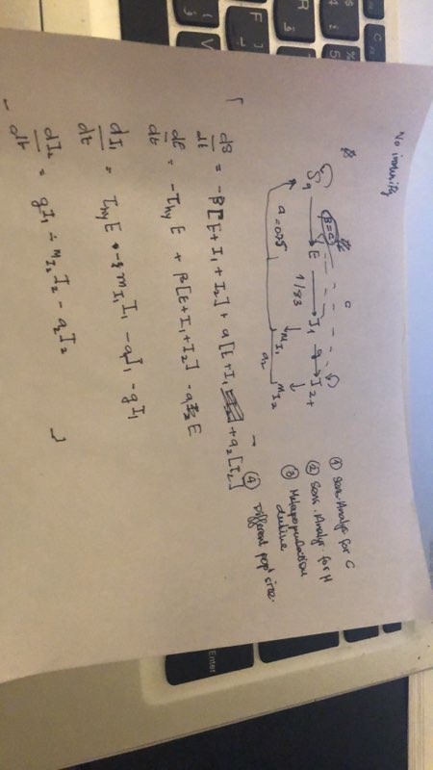

fric

References

Arias-Cóyotl, E., Stoner, K., & Casas, A. (2006). Effectiveness of Bats as Pollinators of Stenocereus stellatus (Cactaceae) in Wild, Managed In situ, and Cultivated Populations in La Mixteca Baja, Central Mexico. *American Journal of Botany,* *93*(11), 1675-1683.

Beekman CN, Meckler L, Kim E, Bennett RJ (2018) Galleria mellonella as an insect model for P. destructans, the cause of White-nose Syndrome in bats

Blehert, D., Hicks, A., Behr, M., Meteyer, C., Berlowski-Zier, B., Buckles, E., . . . Stone, W. (2009). Bat White-Nose Syndrome: An Emerging Fungal Pathogen? Science, 323(5911), new series, 227-227.

Dobony, C. A., & Johnson, J. B. (2018). Observed Resiliency of Little Brown Myotis to Long-Term White-Nose Syndrome Exposure. Journal of Fish and Wildlife Management, 9(1), 168-179.

Dubois, J. E., & Monson, K. M. (2007). Recent Distribution Records of the Little Brown Bat, *Myotis lucifugus*, in Manitoba and Northwestern Ontario. *The Canadian Field-Naturalist*, *121*(1), 57.

Frick, W. F., J. F. Pollock, A. C. Hicks, K. E. Langwig, D. S. Reynolds, G. G. Turner, C. M. Butchkoski, and T. H. Kunz. 2010a. An emerging disease causes regional population collapse of a common North American bat species. Science 329(5992): 679-682.

Frick, W. F., Puechmaille, S. J., & Willis, C. K. (2016). White-nose syndrome in bats. In Bats in the Anthropocene: Conservation of bats in a changing world (pp. 245-262). Springer, Cham.

Hanski, I. (1998), Metapopulation dynamics. *Nature*, 396: 41-49.

Hoyt, J. R., Langwig, K. E., Okoniewski, J., Frick, W. F., Stone, W. B., & Kilpatrick, A. M. (2015). Long-term persistence of Pseudogymnoascus destructans, the causative agent of white-nose syndrome, in the absence of bats. EcoHealth, 12(2), 330-333.

Ivar Vleut, Samuel I. Levy-Tacher, Jorge Galindo-González, Willem F. de Boer. 2015. Positive effects of surrounding rainforest on composition, diversity and late-successional seed dispersal by bats. *Basic and Applied Ecology*. 16:308-315

Langwig KE, Frick WF, Bried JT, Hicks AC, Kunz TH, Kilpatrick AM (2012) Sociality, density-dependence and microclimates determine the persistence of populations suffering from a novel fungal disease, white-nose syndrome. Ecol Lett 15:1050–1057

Langwig, K. E., Hoyt, J. R., Parise, K. L., Frick, W. F., Foster, J. T., & Kilpatrick, A. M. (2017). Resistance in persisting bat populations after white-nose syndrome invasion. Philosophical Transactions of the Royal Society B: Biological Sciences, 372(1712), 20160044.

Lorch, J., Lindner, D., Gargas, A., Muller, L., Minnis, A., & Blehert, D. (2013). A culture-based survey of fungi in soil from bat hibernacula in the eastern United States and its implications for detection of Geomyces destructans, the causal agent of bat white-nose syndrome. *Mycologia,* *105*(2), 237-252.

Lorch, J. M., Muller, L. K., Russell, R. E., O'Connor, M., Lindner, D. L., & Blehert, D. S. (2013). Distribution and environmental persistence of the causative agent of white-nose syndrome, Geomyces destructans, in bat hibernacula of the eastern United States. Appl. Environ. Microbiol., 79(4), 1293-1301.

Maher, S. P., Kramer, A. M., Pulliam, J. T., Zokan, M. A., Bowden, S. E., Barton, H. D., ... & Drake, J. M. (2012). Spread of white-nose syndrome on a network regulated by geography and climate. Nature communications, 3, 1306.

Palmer, J. M., Drees, K. P., Foster, J. T., & Lindner, D. L. (2018). Extreme sensitivity to ultraviolet light in the fungal pathogen causing white-nose syndrome of bats. Nature communications, 9(1), 35.

Wilder, A. P., Frick, W. F., Langwig, K. E., & Kunz, T. H. (2011). Risk factors associated with mortality from white-nose syndrome among hibernating bat colonies. *Biology letters*, *7*(6), 950–953.

Norquay, K. J. O., F. Martinez-Nunez, J. E. Dubois, K. M. Monson, and C. K. R. Willis. 2013. Long-distance movements of little brown bats (Myotis lucifugus). Journal of Mammalogy 94(2): 506-515.

Smith, E. (1957). Experimental study of factors affecting sex ratios in the little brown bat. Journal of Mammalogy, 38(1), 32-39.

Verant, M. L., Boyles, J. G., Waldrep Jr, W., Wibbelt, G., & Blehert, D. S. (2012). Temperature-dependent growth of Geomyces destructans, the fungus that causes bat white-nose syndrome. PloS one, 7(9), e46280.

Wilcox, A., Warnecke, L., Turner, J. M., McGuire, L. P., Jameson, J. W., Misra, V., ... & Willis, C. K. (2014). Behaviour of hibernating little brown bats experimentally inoculated with the pathogen that causes white-nose syndrome. Animal Behaviour, 88, 157-164.

Wilder, A. P., Frick, W. F., Langwig, K. E., & Kunz, T. H. (2011). Risk factors associated with mortality from white-nose syndrome among hibernating bat colonies. Biology Letters, 7(6), 950-953.